AI for Developers – January 2026
Individual Project Assignment

Project
ScalesApp is a web-based weighing station management system designed to record and track vehicle weights in real time. The system connects to an industrial weighing scale via a serial (COM) port, reads weight measurements continuously, and allows operators to register tare and gross weights for individual vehicles.
The application consists of three main components: a Django REST API backend that stores vehicle records and user data in a PostgreSQL database; a React single-page frontend that displays the live weight feed and lets operators manage weighings; and a standalone serial bridge service that reads data from the COM port and streams it to the frontend via Server-Sent Events. User access is secured with JWT authentication and role-based permissions. The system also includes a configurable report builder for generating custom weighing documents.
Key system requirements: real-time weight display with automatic COM port reconnection; persistent storage of tare, gross, and net weights per vehicle with operator and timestamp tracking; dynamic extra fields (cargo type, destination, etc.) configurable at runtime without code changes; role-based access control (employee / viewer / admin); and a drag-and-drop report designer that can produce printable weighing documents.

System Architecture – Modules
1. Serial Bridge (Flask + pyserial)
A lightweight standalone Python service that continuously reads weight data from the industrial scale over a serial (COM) port using pyserial. It exposes a Flask SSE endpoint on port 5000 that streams raw weight values to the frontend in real time. The bridge runs independently from Django — it can be restarted without affecting the backend — and ships as a Windows system-tray executable. The frontend connects directly to this service via the browser’s native EventSource API.
2. Django REST API Backend
The core server built with Django and Django REST Framework, served via ASGI (uvicorn). It is split into three Django apps: api (users, JWT auth, COM port log, report templates), vehicles (vehicle records with tare/gross/net weights and VehicleExtra for dynamic fields), and nomenclatures (runtime-configurable lookup tables and custom field definitions). Every mutation broadcasts a Server-Sent Events message through a shared async queue so all connected frontends receive live updates. PostgreSQL is used as the database in production.
3. React SPA Frontend
A single-page React application on port 3000. State is managed through three React Contexts: AuthContext handles JWT access/refresh token lifecycle and axios interceptors; NomenclatureContext subscribes to the Django SSE endpoint and maintains an in-memory cache of all vehicles, nomenclature entries and dynamic field definitions; DataContext and BandContext serve the report preview mode. The main weighing screen (Main.jsx) shows a vehicle list on the left, live scale weight at the top, and a dynamic detail panel on the right where operators set tare and gross weights. The frontend also contains a full drag-and-drop report designer (ReportEditor).
4. Nomenclature / Dynamic Field System
A runtime-configurable schema layer that lets administrators define extra data fields for vehicles (e.g. cargo type, destination, driver) through the Django admin or API, without any code changes or database migrations. Each Nomenclature can be a lookup table (dropdown with predefined entries) or a free-form field (text, number, boolean, choice). Values are stored as JSON in a VehicleExtra model that has a OneToOne relationship with Vehicle. The frontend dynamically renders the correct input controls based on the active nomenclature definitions it receives at startup.
5. Authentication & Authorisation Layer
JWT-based authentication provided by djangorestframework-simplejwt. Access tokens expire after 15 minutes; refresh tokens last 7 days. The React frontend auto-refreshes tokens every 14 minutes via a background interval and queues in-flight requests during the refresh cycle. Users carry a role field (employee / viewer) and an is_admin flag that gates access to the Django admin panel. The SSE connection is authenticated by passing the access token as a query parameter on the EventSource URL.
6. Report Builder
A custom drag-and-drop report designer built entirely in React (ReportEditor). The canvas uses a character grid (80 × 66 cells). Element types include static text, data-bound fields (DBTextElement with configurable object key and field path), borders, lines, symbols, and band elements for repeating sections (header, detail, footer, summary). Completed report layouts are serialised to JSON and saved to the Django Report model. A preview mode fetches live data from a configurable API endpoint and renders the report with actual values, iterating over band rows via BandContext.

Development Process per Module
Module 1: Serial Bridge (Flask + pyserial)
Approach & reasoning: The scale outputs weight data as ASCII strings over RS-232. A dedicated Flask process was chosen instead of integrating with Django so the COM connection stays alive independently of backend restarts. SSE was selected as the transport because the browser’s native EventSource API handles reconnection automatically without extra client code.
Step-by-step workflow: Asked Claude Code to generate the SerialPortReader threading class and background queue, then the Flask /events SSE endpoint, then the Windows system-tray icon via pystray, and finally the PyInstaller spec for a single-file executable.
Testing strategy: Used com0com to create a virtual COM port pair and a test_writer.py script that emits simulated weight readings at a configurable interval, enabling end-to-end testing without physical hardware.
AI tool choice: Claude Code — it maintained context across all four source files simultaneously and produced the threading/queue pattern correctly in one pass.
Key prompts: “I need a python project that reads data from comport and has a SSE endpoint. When there is an SSE connection, it sends the read data and/or keep-alive heartbeat”.
Module 2: Django REST API Backend
Approach & reasoning: Standard DRF ModelViewSet pattern for all resources, with custom @action decorators for domain operations (set_tare, set_gross). An ASGI server (uvicorn) was required once the async SSE broadcast endpoint was introduced.
Step-by-step workflow: Scaffolded three Django apps (api, vehicles, nomenclatures), then for each app generated models → serializers → viewsets → URL registration. Added sse_broadcast_update calls to every mutation, then migrated from WSGI runserver to uvicorn/ASGI.
Testing strategy: Django’s built-in test client for CRUD endpoints; Postman for manual JWT token-flow and weight-setting action tests.
AI tool choice: Claude Code — handles Django’s repetitive boilerplate and tracks the relationships between models, serializers, viewsets, and URL patterns across multiple files without losing consistency.
Key prompts: “when both tare and gross are filled out, net should be calculated and saved (at backend). doc_number should be generated and assigned to the vehicle record.“
“Create a Vehicle ModelViewSet with set_tare and set_gross @action endpoints that record the current user and timestamp, then call sse_broadcast_update”; “I need a SSE that authenticates via a JWT and replays up to 100 missed/new events. Reconnects on error or missed event”.
Module 3: React SPA Frontend
Approach & reasoning: State is split into focused Contexts: AuthContext owns the JWT lifecycle, NomenclatureContext owns all server data and the live SSE subscription. Components receive only what they need via context hooks, keeping the main view component free of data-fetching logic.
Step-by-step workflow: Built AuthContext with axios interceptors and the refresh-queue pattern first; then NomenclatureContext with SSE subscription and live state updates; then Main.jsx with the split-panel layout (vehicle list left, live weight top, detail panel right).
Testing strategy: Manual browser testing. SSE reconnection was validated by restarting the uvicorn server mid-session and confirming the UI recovered without a page reload.
AI tool choice: Claude Code — generated complete, functional JSX components and custom hooks in a single pass while keeping multi-file context coherent.
Key prompts: “I need a React application that connects to my Django server, authenticates via jwt. Implement user login and change password.”. “The app should connect to the SSE api of the backend and manage incoming data changes.”
“on dbfield, lets add some more options. I need it to have a type and alignment. type should be general, number, date, time, datetime, and alignment should be left, centered, right. if type is a date, try to get only date from the value etc. if impossible, show empty. Alignment is default left. If something else is selected, align the data in the field properly”
“I need when a vehicle gets his second measurement, meaning it has both tare and gross filled out, this triggers a document to be shown. name of the document is notice_report, it is opened in preview mode, and the data should contain all the fields of the vehicle record. For testing, let's make a button in the net panel, that calls this report with the current vehicle data”
Module 4: Nomenclature / Dynamic Field System
Approach & reasoning: Field schemas are stored in three related models (Nomenclature, NomenclatureField, NomenclatureEntry) and values saved as a JSON blob on VehicleExtra. Validation is enforced in the serializer rather than by DB constraints, so the schema can be changed at runtime without any migration.
Step-by-step workflow: Designed the three models together with Claude Code, then wrote the VehicleExtraSerializer validate method with the dynamic type-checking loop, then implemented the frontend rendering that maps each NomenclatureField type to the appropriate React input control.
Testing strategy: Created test nomenclatures in Django admin (cargo type as a lookup dropdown, driver name as free text, axle count as a number) and confirmed the frontend rendered the correct controls and rejected out-of-range values.
AI tool choice: Claude Code — generated the serializer validation loop that iterates over active NomenclatureFields and applies type-specific checks on the submitted JSON values.
Key prompts: “Write a DRF serializer validate method that reads active NomenclatureField definitions and enforces text/number/bool/choice type constraints on a JSONField”; “Render a list of nomenclature definitions in React, switching the input component based on the kind and field_type values”.
Module 5: Authentication & Authorisation Layer
Approach & reasoning: djangorestframework-simplejwt issues short-lived access tokens (15 min) and long-lived refresh tokens (7 days). Role-based access is enforced via DRF permission classes on each viewset so viewers cannot trigger any write operations.
Step-by-step workflow: Configured simplejwt settings and a custom TokenObtainPairSerializer that embeds role and is_admin into the payload. Wrote AuthContext with a 14-minute refresh interval and a promise queue that pauses concurrent requests during a refresh. Added permission classes to viewsets.
Testing strategy: Temporarily reduced the access token lifetime to 30 seconds in development settings and confirmed the frontend refreshed silently and continued working without any user-visible interruption.
AI tool choice: Claude Code — produced the promise-queue interceptor pattern and the custom simplejwt serializer in a single interaction.
Key prompts: “Write an axios interceptor that catches 401 errors, queues all concurrent requests, refreshes the token once, then replays every queued request with the new access token”; “Add a custom TokenObtainPairSerializer that includes the user’s role and is_admin fields in the JWT payload”.
Module 6: Report Builder
Approach & reasoning: A character-grid coordinate system (80x66 cells) was chosen to avoid pixel-rounding issues and map naturally to fixed-width print output. Element types are a JS class hierarchy with a shared base, serialised to plain JSON for storage in the Django Report model.
Step-by-step workflow: Built the Element class hierarchy (TextElement, DBTextElement, FrameElement, BandElement, etc.) first, then EditorCanvas with drag-drop and resize-handle logic, then ObjectInspector for property editing. Band elements and BandContext for preview iteration were added last.
Testing strategy: Visual testing — designed a sample vehicle weighing report, saved it to Django, reloaded the editor, and verified the layout was restored identically. Preview mode was tested against the live vehicles API endpoint to confirm data-bound fields rendered correct values.
AI tool choice: Claude Code — provided the coordinate math for grid-snapping and multi-element drag, and generated the BandContext provider/consumer pattern correctly in one pass.
Key prompts: “Calculate the snapped grid position from a mouse drag event on a character-grid canvas, accounting for scroll offset and the element grab origin”; “Write a React Context that iterates over an array of data rows and exposes the current row to child DBTextElements during print preview”; “Add multi-select with a rubber-band selection rectangle and group drag on the editor canvas”.

Challenges & Tool Comparison
A section where you explain:
- The biggest challenge was to explain to the AI the concept of the document editor, bands, fields, sample data etc. It continuously messed up positions of the elements, handles were not placed on field edges, field widths did not match visually. Fields in bands were painted outside the band but moved with it.
- I only used Claude Code, as I have paid subscription for it, because of other projects. At first Claude Code was smart and fast, then with v4.5 things got a bit worse, but lately it has been behaving much better. Did not notice any hallucinating or intentional playing “dumb”.
- I have a lot of things still to do on the project.

- First, I want to change the UI. I plan to do that with Copilot and Gemini or Antigravity, as Gemini produces more ;

- I want to make a “smart” comport reader, that can understand the pattern of the scales protocol without being provided such (many customers have no technical background nor description about it);

- I also need to make a parametrized reports, for example vehicles for the current month or for a specific period;

- For the test purpose, the comport reader is now installed on the server, it has to be installed on client’s machine;

- expression field in Document creator;

- etc.

Working System Evidence
Screenshot of the vehicle weighting page:

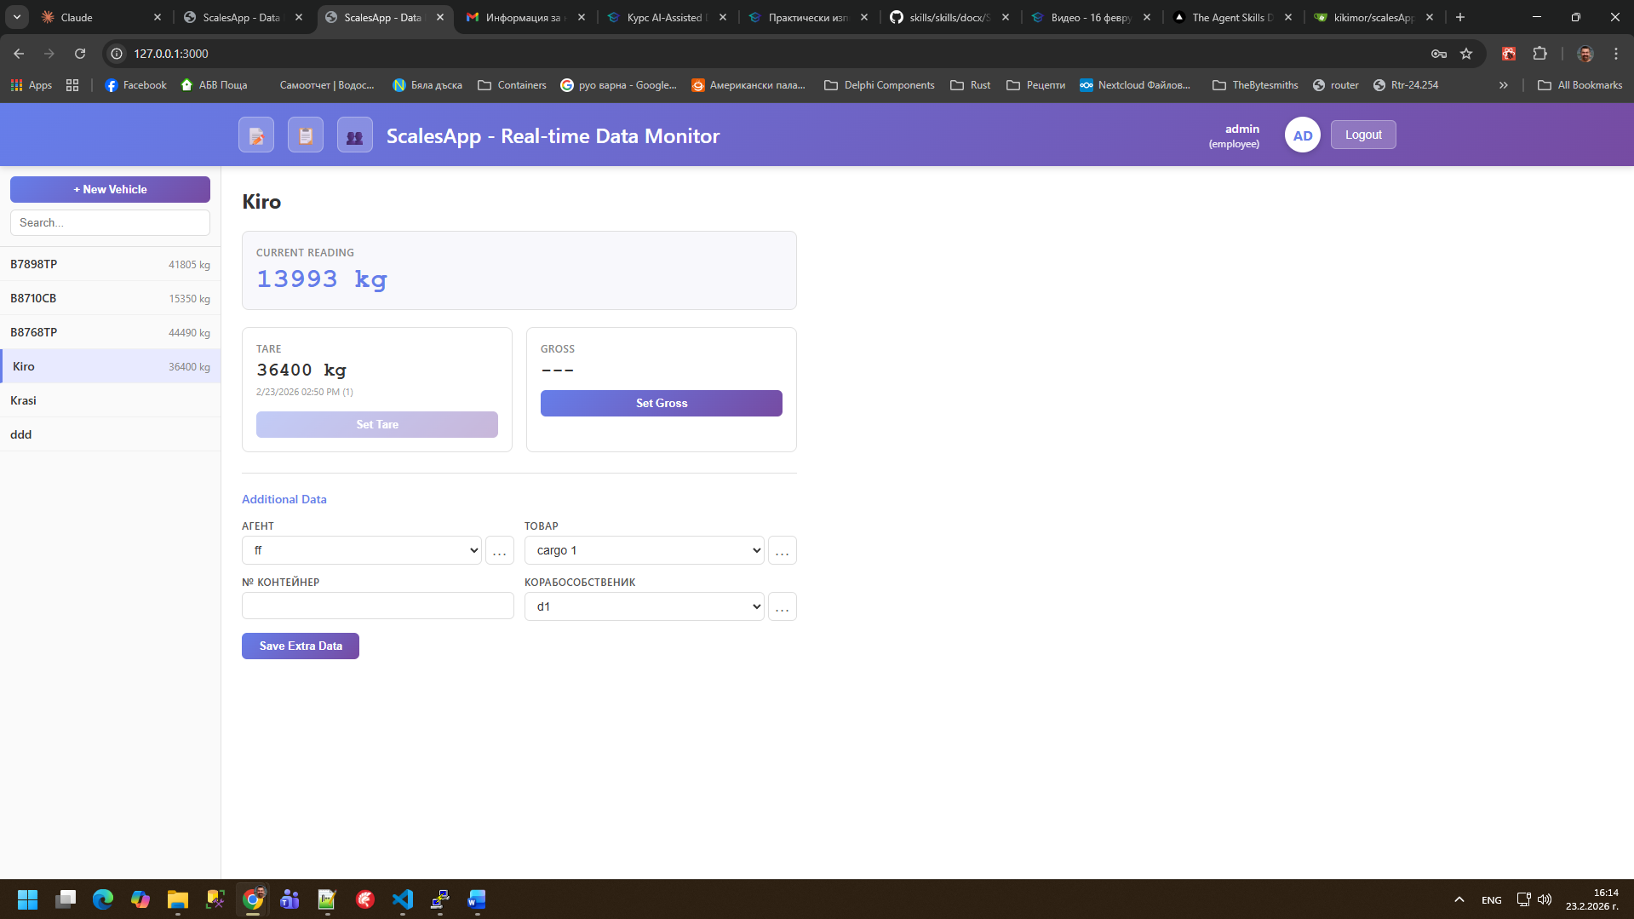

Screenshot of Document Editor:
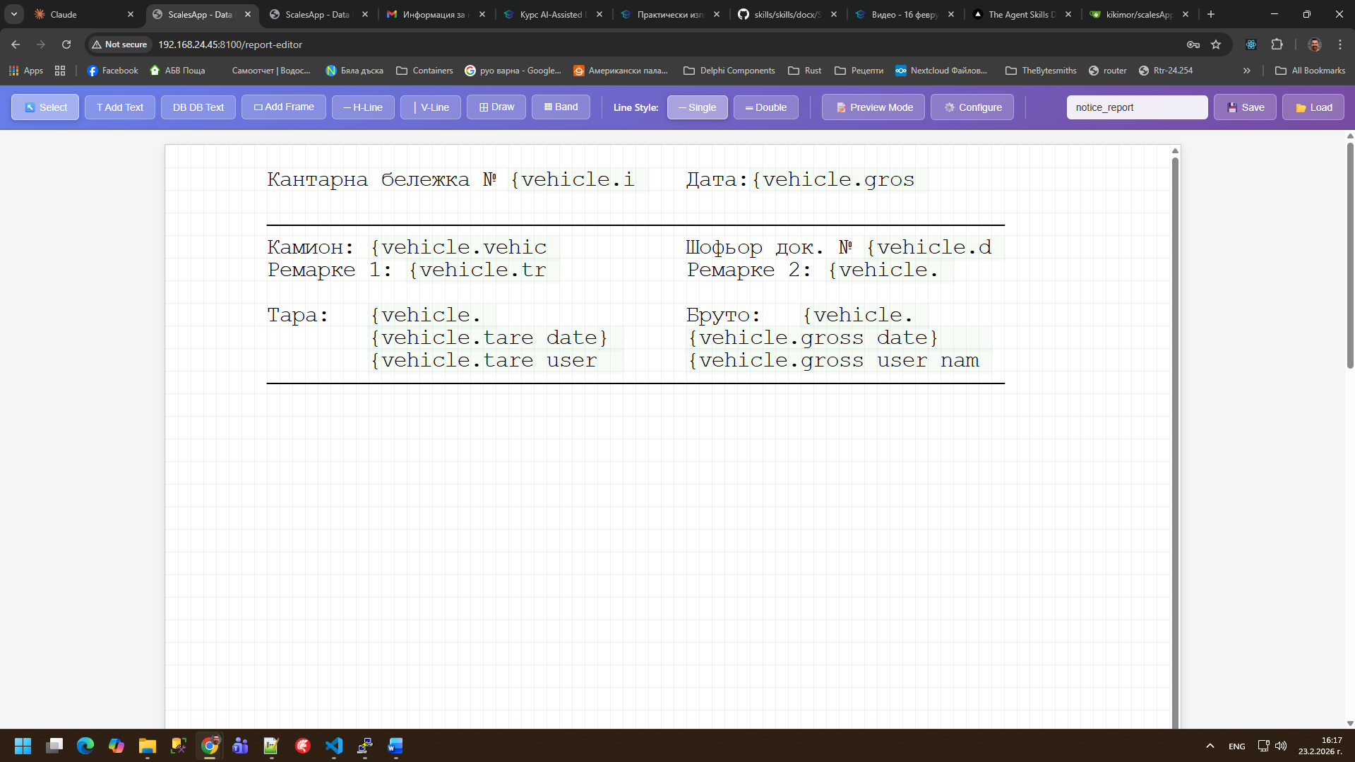

Screenshot of the Dynamic nomenclatures management page:
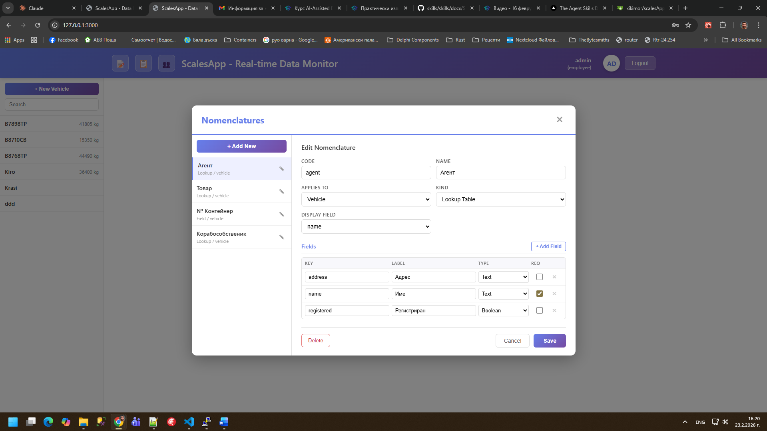

Repository
GitHub repository: https://git.kikimor.com/kikimor/scalesApp

Working app: https://scales.kikimor.com
User: admin
Password: admin

